statistical analysis

Table of Contents

INTRODUCTION 1

Relationship between dividend Policy and Stock Prices 1

RESULT AND DISCUSSION 2

Descriptive statistics: 2

MODEL SUMMARY: 3

Dividend with SP 3

Dividend with ESP 3

Dividend with Tax 3

ESP With stock price: 4

CONCLUSION: 4

# INTRODUCTION

A dividend announcement is one of the most decisive events, usually having an impact on, among others, investor sentiment and stock price. A company's payout policy, or dividend policy, is a crucial financial decision that affects how much is distributed to shareholders over time. Dividends are essential to increasing investor wealth and utility and have a major impact on a company's value. Dividends contribute to a decrease in the agency costs of free cash flows by addressing issues related to overinvestment.

Against this backdrop, the current study applies regression analysis to measure the relationship between dividend announcements and stock valuation, along with exploring potential differences within the banking systems of the United Kingdom and the United States of America.

They use a dataset that includes dividend announcement data together with stock prices and other related variables for regression models on the effect of dividend announcements on stock valuation. That is, it controls for elements that include market conditions, measures of financial performance, and regulatory environments.

The report has outlined the factors driving stock valuation post-announcement of dividends within the banking sector. This comparative analysis, in this case, brings to the fore any divergent patterns of investor behavior between UK and USA banks to dividend announcements.

# Relationship between Stock Prices and dividend Policy

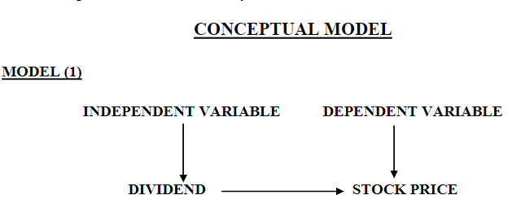

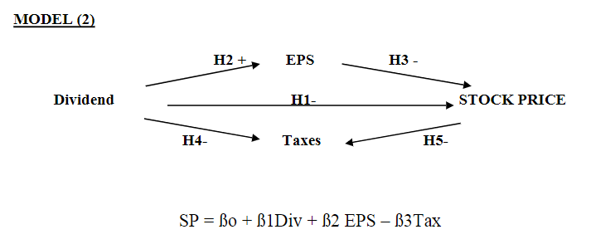

H1: There exists a negative association between dividend and stock price.

H2: Dividend and EPS exhibit a positive relationship.

H3: A negative correlation exists between stock price and earnings per share.

H4: There is a negative relationship between dividend and tax. H5: Stock price and tax demonstrate a negative relationship.

# RESULT AND DISCUSSION

## Descriptive statistics:

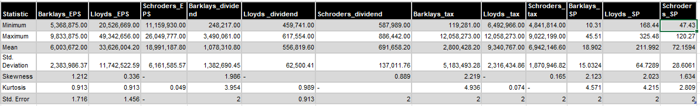

Table 2: Summary statistics for selected key financial variables across banks chosen in the study.

The table shows the minimum, maximum, mean, and standard deviation for each of the variables that are under the discussion, pointing to what lengths the data tends to move from the average. The statistics of skewness and kurtosis provide measures by which one can compute the symmetry of the data and its peakedness, respectively. It gives information about the distributional information of the variables in a way to guide the further analysis and results interpretation.

## MODEL SUMMARY:



## Dividend with SP

The hypothesis, with a t-value of 2.109 and a beta coefficient of .227, points to a negative link between dividends and stock price. But since the p-value is higher than 0.05, the significance is disproved. As a result, hypothesis H1 is disproved. According to the regression model SP = ßo + ß1Div + ß2 EPS – ß3Tax, there is a negative correlation between dividends and stock price.

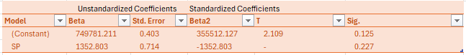

## Dividend with ESP

This implies a negative relationship between the earnings per share and dividend, with a beta coefficient value of 1.96 and a t-value of -4.608. Since the p-value is less than 0.05, it accepts the significance; hence, it is the reason for the acceptance of H2. The regression model indicates that earnings per share has a positive association with dividends.

## Dividend with Tax

Here, the beta coefficient of 0.648 and the corresponding t-value of 2.707 at the given significance level of p < 0.05, according to t-distribution tables, exhibit that for the specified level of significance, the hypothesis for a negative relationship between dividends and taxes is proved correct. This means hypothesis (H3) can be accepted. From the regression equation, dividends show a positive relation, and tax implications go on increasing with an increase in dividends payout.

## ESP With stock price:

These results for this hypothesis would mean that the dividend and tax have a negative relation since beta = 0.016, t = 4.906, and its significance is also rejected since the value is less than p = 0.05.

This means that H4 SP = ßo + ß1Div + ß2 EPS – ß3Tax is the accepted hypothesis.

It is established that there is a negative correlation between stock price and earnings per share.

ESP in conjunction with stock price

# CONCLUSION:

This finding reports, therefore, that fluctuations in the payment of dividends do significantly contribute to a change in stock prices in all the sampled banking sectors, specifically under changes in dividends which are inversely related to stock prices. The same is applicable for all three different types of banking sectors observed in this research. Although dividends are positively related to other variables, such as earnings per share, one of the things to be noted is that stock prices show a negative correlation with earnings per share. In this respect, the results underline complex dynamics between dividend policies, stock prices, and key financial indicators in the banking sector.

# APPENDIX:

## DATA:

Contains the information of bank dividends, SP and ESP.

